**CS 323 Exam 2**

**Problem 1**

1. Extract 12 sampling points form Mar 2020 to the present
   1. Mar 2020: 200
   2. Apr 2020: 3400
   3. May 2020: 2000
   4. Jun 2020: 400
   5. Jul 2020: 300
   6. Aug 2020: 350
   7. Sep 2020: 500
   8. Oct 2020: 1500
   9. Nov 2020: 2800
   10. Dec 2020: 5000
   11. Jan 2021: 6000
   12. Feb 2021: 4000
2. Cubic Spline
   1. 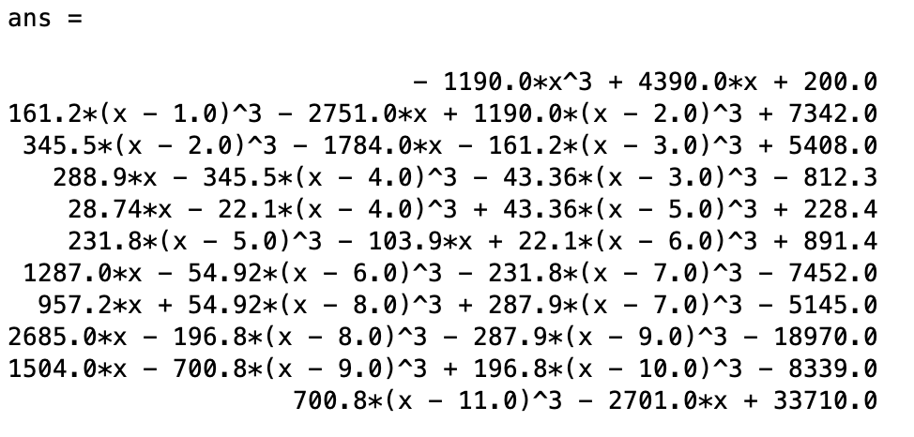
   2. 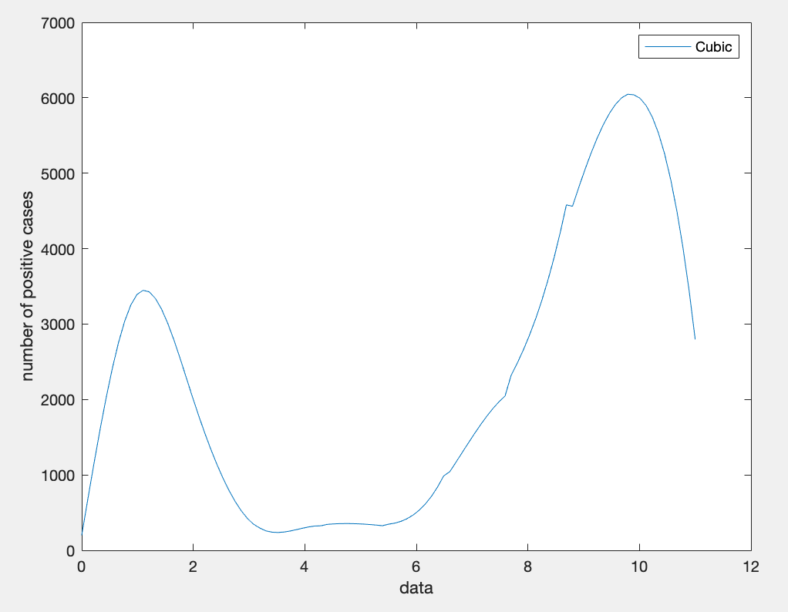
3. Trapezoid:

**Problem 2**

